EB29(92)Y-80D-B
100G QSFP28 ZR4 BIDI Optical Transceiver

PRODUCT FEATURES
- Support line rates from 103.125 Gb/s;
- Lane bit rate 25.78 Gb/s 100GE
- Up to 80km transmission with KR4-FEC.
- LAN WDM EML laser and PIN receiver with SOA;
- Support Multi-Pin function with IntL/RxLOSL and LPMode/TxDIS;
- High speed I/O electrical interface (CAUI-4);
- I2C interface with integrated Digital Diagnostic monitoring;
- QSFP28 MSA package with simplex LC connector;
- Single +3.3V power supply
Power dissipation
Commercial：< 5.5W
- Complies with EU Directive 2015/863/EU

APPLICATIONS
- 100GBASE-ZR4 Ethernet
- 100G Datacom& Telecom connections

Description
The EB29(92)Y-80D-B is designed for 80km optical communication applications. Optical transceiver integrates the transmit and receive path onto one module. On the transmit side, four lanes of serial data streams are recovered, retimed, and passed on to four laser drivers, which control four electric-absorption modulated lasers (Lan-WDM) with 1273,1278,1282,1286, 1296, 1300, 1305, and 1309 nm center wavelengths. The optical signals are then multiplexed into a single-mode fiber through an industry-standard LC connector. On the receive side, four lanes of optical data streams are optically DE multiplexed by an integrated optical DE multiplexer. After the optical signal is amplified by SOA, DEMUX separates four channels which are recovered by PIN photodetector and cross-impedance amplifier, retimed and passed on to an output driver. This module features a hot-pluggable electrical interface, low power consumption, and 2-wire serial interface.

Module Block Diagram
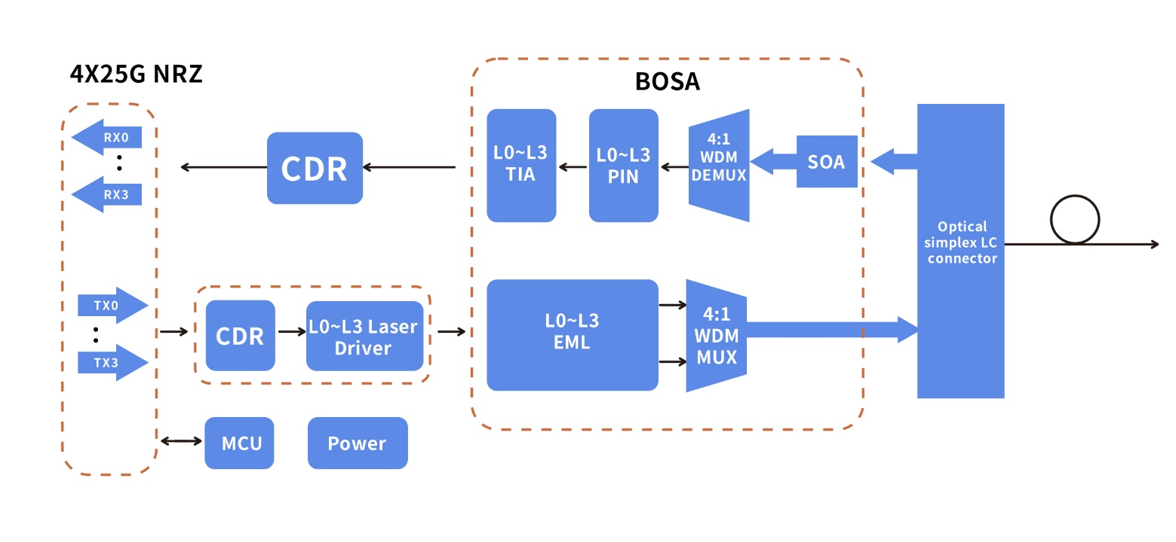

Ordering information
Part No. | Data Rate(Gbps) | Laser | Fiber Type | Transmission Distance(km) | Optical Interface | Temp（℃） | DDMI
EB29Y-80D-B | 103.125 | LWDM | SMF | 80 | LC | 0~70 | Y
EB92Y-80D-B | 103.125 | LWDM | SMF | 80 | LC | 0~70 | Y

Model wavelength specification
Part No. | TX Center Wavelength | RX Center Wavelength
EB29Y-80D-B | Lane0 1273.55 | Lane0 1295.56
EB29Y-80D-B | Lane1 1277.89 | Lane1 1300.05
EB29Y-80D-B | Lane2 1282.26 | Lane2 1304.58
EB29Y-80D-B | Lane3 1286.66 | Lane3 1309.14
EB92Y-80D-B | Lane0 1295.56 | Lane0 1273.55
EB92Y-80D-B | Lane1 1300.05 | Lane1 1277.89
EB92Y-80D-B | Lane2 1304.58 | Lane2 1282.26
EB92Y-80D-B | Lane3 1309.14 | Lane3 1286.66
Recommend Operating Conditions
Parameter | Symbol | Min | Typ | Max | Unit | Notes
Operating Case Temperature | Top | 0 |  | +70 | °C
Operating Case Temperature | VCC | 3.14 | 3.3 | 3.47 | V
Maximum Power Dissipation | P_{D} |  |  | 5.5 | W
Lane Bit Rate |  |  | 25.78125 |  | Gb/s
Transmission Distance | TD |  |  | 80 | km
Coupled fiber | Single mode fiber |  |  |  |  | 1
Notes:
- Optical fiber use 9/125um SMF.
Absolute Maximum Ratings
It has to be noted that the operation in excess of any individual absolute maximum ratings might cause permanent damage to this module.
Parameter | Symbol | Min | Max | Unit | Notes
Storage Temperature | TS | -40 | 85 | degC
Operating Case Temperature | TOP | 0 | 70 | degC
Power Supply Voltage | VCC | -0.5 | 3.6 | V
Damage Threshold, each Lane | THd | 5.5 |  | dBm
RelativeHumidity (non-condensation) | RH | 0 to 85% non-condensing |  | %

The following characteristics are defined over the Recommended Operating Environment unless otherwise specified.
Electrical Characteristics
The following electrical characteristics are defined over the Recommended Operating Environment unless otherwise specified.
Parameter | Test Point | Min | Typ | Max | Unit | Notes
Transmitter (Module Input)
Data Rate, each lane |  |  | 25.78125 |  | Gbps
Differential Voltage pk-pk | Vpp |  |  | 900 | Mv | 1
Common Mode Voltage | Vcm | -350 |  | 2850 | Mv
Transition time | Trise/Tfall | 10 |  |  | ps | 2
Receiver (Module Output)
Data Rate, each lane |  |  |  |  | 25.78125
Common Mode Noise, RMS | Vrms |  |  | 17.5 | Mv
Differential output voltage swing | Vout, pp |  |  | 900 | Mv
Eye width | EW15 | 0.57 |  |  | UI
Eye height | EH15 | 228 |  |  | mV
Differential Termination Resistance Mismatch |  |  |  | 10 | % | 1
Transition time | Trise/Tfall | 12 |  |  | ps
Data Rate, each lane |  |  | 25.78125 |  | Gbps
Common Mode Noise, RMS | Vrms |  |  | 17.5 | Mv
Notes:
  - At 1 MHz.
  - 20%~80%.
Optical Characteristics
Parameter | Symbol | Min | Typ | Max | Unit | Note
Transmitter
Signaling Speed per Lane |  |  | 25.78125 |  | Gbps
Center Wavelength Lane 0 | λ0 | 1272.55 | 1273.55 | 1274.54 | nm | EB29Y-80D-B
Center Wavelength Lane 1 | λ1 | 1276.89 | 1277.89 | 1278.89 | nm | EB29Y-80D-B
Center Wavelength Lane 2 | λ2 | 1281.25 | 1282.26 | 1283.27 | nm | EB29Y-80D-B
Center Wavelength Lane 3 | λ3 | 1285.65 | 1286.66 | 1287.68 | nm | EB29Y-80D-B
Center Wavelength Lane 4 | λ4 | 1294.53 | 1295.56 | 1296.59 | nm | EB92Y-80D-B
Center Wavelength Lane 5 | λ5 | 1299.02 | 1300.05 | 1301.09 | nm | EB92Y-80D-B
Center Wavelength Lane 6 | λ6 | 1303.54 | 1304.58 | 1305.63 | nm | EB92Y-80D-B
Center Wavelength Lane 7 | λ7 | 1308.09 | 1309.14 | 1310.19 | nm | EB92Y-80D-B
Total Launch Power, 100GE | P_{T} | 8 |  | 12.5 | dBm | 1
Average Launch Power per Lane, | Pavg | 2 |  | 6.5 | dBm | 1
OMA, each Lane | P_{OMA} | 2 |  | 6.5 | dBm | 1
Difference in launch power between any two lanes(Average and OMA) between any Two Lanes (OMA) | Ptx,diff |  |  | 3 | dB
Average Output Power (Laser Turn off) | P_{off} |  |  | -30 | dBm
Side Mode Suppression Ratio | SMSR | 30 |  |  | dB
Extinction Ratio, 100GE | ER | 6 |  |  | dB
RIN20OMA | RIN |  |  | -130 | dB/Hz
Optical Return Loss Tolerance | TOL |  |  | 20 | dB
Transmitter Reflectance | R_{T} |  |  | -12 | dB
Optical Eye Mask | {0.25,0.4, 0.45, 0.25, 0.28, 0.4} |  |  |  | % | 2
Receiver
Signaling rate, each lane |  |  | 25.78125 |  | Gbps
Center Wavelength Lane 0 | λ0 | 1294.53 | 1295.56 | 1296.59 | nm | EB29Y-80D-B
Center Wavelength Lane 1 | λ1 | 1299.02 | 1300.05 | 1301.09 | nm | EB29Y-80D-B
Center Wavelength Lane 2 | λ2 | 1303.54 | 1304.58 | 1305.63 | nm | EB29Y-80D-B
Center Wavelength Lane 3 | λ3 | 1308.09 | 1309.14 | 1310.19 | nm | EB29Y-80D-B
Center Wavelength Lane 4 | λ4 | 1272.55 | 1273.55 | 1274.54 | nm | EB92Y-80D-B
Center Wavelength Lane 5 | λ5 | 1276.89 | 1277.89 | 1278.89 | nm | EB92Y-80D-B
Center Wavelength Lane 6 | λ6 | 1281.25 | 1282.26 | 1283.27 | nm | EB92Y-80D-B
Center Wavelength Lane 7 | λ7 | 1285.65 | 1286.66 | 1287.68 | nm | EB92Y-80D-B
Damage threshold , each lane | Pdamage | 5.5 |  |  | dBm
Receiver sensitivity Average, each lane | SEN |  |  | -26 | dBm | 3
Los Assert | LosA | -40 |  |  | dBm
Los De-assert | LosDA |  |  | -28 | dBm
Notes:
- The optical power is launched into SMF。
- Measured with a PRBS 2³¹-1 test pattern @25.78125, Hit ratio≤5E-5。
- Measured with a PRBS 2³¹-1 test pattern @25.78125 Gb/s, BER≤5E-5。

Digital Diagnostic Monitoring Specifications
Parameter | Unit | Specification
Temperature Monitor absolute error | ℃ | ± 3.0
Supply Voltage Monitor absolute error | % | ± 5℃
I_bias Monitor absolute error | % | ± 10
Received Power (Rx) Monitor absolute error | dB | ± 3.0
Transmit Power (Tx) Monitor absolute error | dB | ± 3.0
Pin Assignment and Description
.

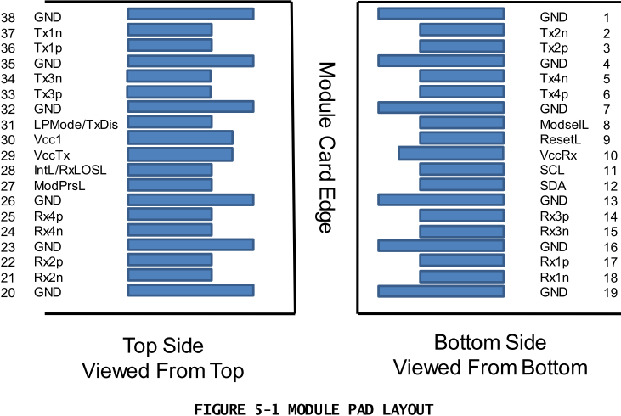

PIN | Logic | Symbol | Description | Plug Seq. | Notes
1 |  | GND | Ground | 1 | 1
2 | CML-I | Tx2n | Transmitter Inverted Data Input | 3
3 | CML-I | Tx2p | Transmitter Non-Inverted Data output | 3
4 |  | GND | Ground | 1 | 1
5 | CML-I | Tx4n | Transmitter Inverted Data Input | 3
6 | CML-I | Tx4p | Transmitter Non-Inverted Data output | 3
7 |  | GND | Ground | 1 | 1
8 | LVTLL-I | ModSelL | Module Select | 3
9 | LVTLL-I | ResetL | Module Reset | 3
10 |  | VccRx | ﹢3.3V Power Supply Receiver | 2 | 2
11 | LVCMOS-I/O | SCL | 2-Wire Serial Interface Clock | 3
12 | LVCMOS-I/O | SDA | 2-Wire Serial Interface Data | 3
13 |  | GND | Ground | 1
14 | CML-O | Rx3p | Receiver Non-Inverted Data Output | 3
15 | CML-O | Rx3n | Receiver Inverted Data Output | 3
16 |  | GND | Ground | 1 | 1
17 | CML-O | Rx1p | Receiver Non-Inverted Data Output | 3
18 | CML-O | Rx1n | Receiver Inverted Data Output | 3
19 |  | GND | Ground | 1 | 1
20 |  | GND | Ground | 1 | 1
21 | CML-O | Rx2n | Receiver Inverted Data Output | 3
22 | CML-O | Rx2p | Receiver Non-Inverted Data Output | 3
23 |  | GND | Ground | 1 | 1
24 | CML-O | Rx4n | Receiver Inverted Data Output | 3 | 1
25 | CML-O | Rx4p | Receiver Non-Inverted Data Output | 3
26 |  | GND | Ground | 1 | 1
27 | LVTTL-O | ModPrsL | Module Present | 3
28 | LVTTL-O | IntL/Rx_LOS | Interrupt/Rx_LOS | 3
29 |  | VccTx | +3.3 V Power Supply transmitter | 2 | 2
30 |  | Vcc1 | +3.3 V Power Supply | 2 | 2
31 | LVTTL-I | LPMode/TxDIS | Low Power Mode/Tx_Disable | 3
32 |  | GND | Ground | 1 | 1
33 | CML-I | Tx3p | Transmitter Non-Inverted Data Input | 3
34 | CML-I | Tx3n | Transmitter Inverted Data Output | 3
35 |  | GND | Ground | 1 | 1
36 | CML-I | Tx1p | Transmitter Non-Inverted Data Input | 3
37 | CML-I | Tx1n | Transmitter Inverted Data Output | 3
38 |  | GND | Ground | 1 | 1

Notes:
- GND is the symbol for signal and supply (power) common for the QSFP28 module. All are common within the QSFP28 module and all module voltages are referenced to this potential unless otherwise noted. Connect these directly to the host board signal-common ground plane.
- Vcc Rx, Vcc1 and Vcc Tx are the receiver and transmitter power supplies and shall be applied concurrently. Requirements defined for the host side of the Host Edge Card Connector are listed in MSA. The connector pins are each rated for a maximum current of 1000 Ma.

Recommended Interface Circuit
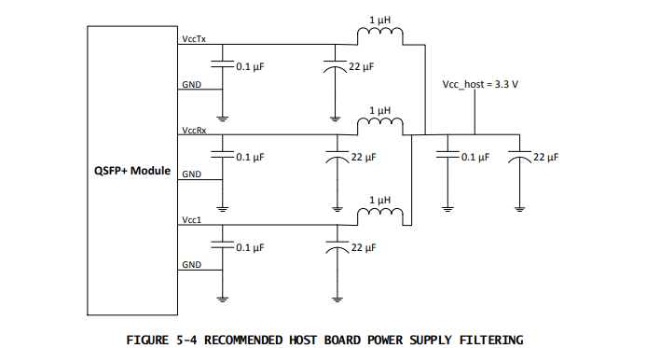
Mechanical Dimensions
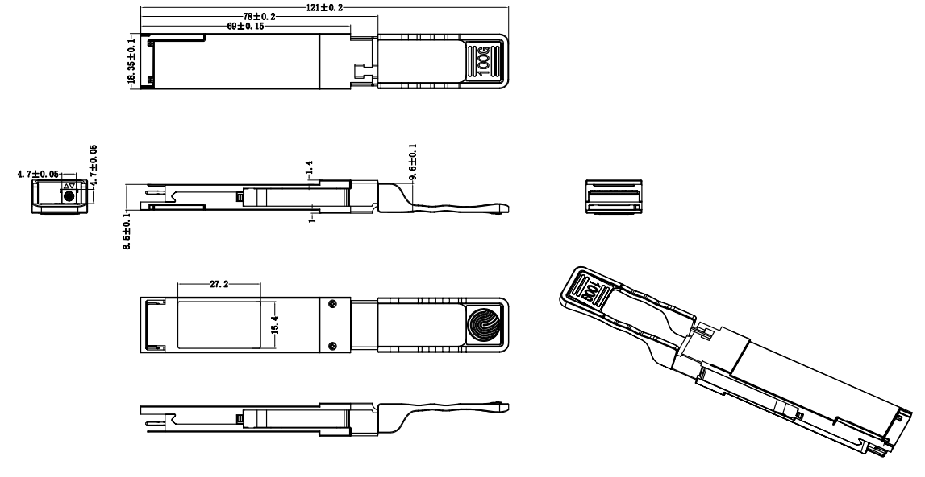

Version No. | Date | Description
1.0 | Aug,17, 2024 | Preliminary datasheet
Revision History

