100Gb/s QSFP28 ZR4 Transceiver
HTQS-HS4CZ

Features
- Compliant with 100GBASE-ZR4
- Support line rates from 103.125 Gb/s to 111.81 Gb/s OTU4
- LAN WDM EML laser and PIN receiver with SOA
- Up to 80km reach for G.652 SMF
- Hot pluggable 38 pin electrical interface
- QSFP28 MSA compliant
- Duplex LC optical receptacle
- RoHS-10 compliant and lead-free
- Single +3.3V power supply
- Maximum power consumption 6.5W
- Case operating temperature
Commercial: 0 ~ +70ºC
Extended: -10 ~ +80ºC
Industrial: -40 ~ +85ºC

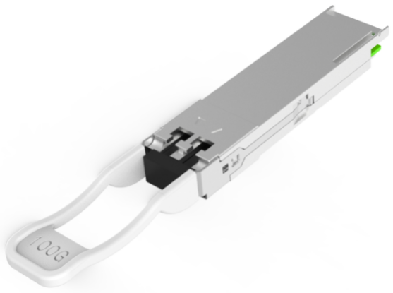

Applications
- 100GBASE-ZR4 Ethernet Links
- Infiniband QDR and DDR interconnects
- Telecom networking
.0

Part Number Ordering Information
Part Number | Data Rate (Gb/s) | Wavelength (nm) | Transmission Distance(km) | Temperature (ºC) (Operating Case)
HTQS-HS4CZC | 103.1 | 1295.56, 1300.05, 1304.58, 1309.14 | 80 | 0~70 commercial
HTQS-HS4CZE | 103.1 | 1295.56, 1300.05, 1304.58, 1309.14 | 80 | -10~80 Extended
HTQS-HS4CZI | 103.1 | 1295.56, 1300.05, 1304.58, 1309.14 | 80 | -40~85 Industrial

I. Absolute Maximum Ratings
It has to be noted that the operation in excess of any individual absolute maximum ratings might cause permanent damage to this module.
Parameter | Symbol | Min | Max | Unit | Notes
Storage Temperature | T_{S} | -40 | 85 | ºC
Power Supply Voltage | V_{CC} | -0.3 | 4.0 | V
Relative Humidity (non-condensation) | RH | 15 | 85 | %
Damage Threshold | TH_{d} | 6.5 |  | dBm
II. Recommended Operating Conditions
Parameter | Symbol | Min | Typical | Max | Unit | Notes
Operating Case Temperature | T_{OP} | 0 |  | 70 | ºC | commercial
Operating Case Temperature | T_{OP} | -10 |  | 80 | ºC | extended
Operating Case Temperature | T_{OP} | -40 |  | 85 | ºC | Industrial
Power Supply Voltage | V_{CC} | 3.135 | 3.3 | 3.465 | V
Data Rate, each Lane |  |  | 25.78125 |  | Gb/s
Control Input Voltage High |  | 2 |  | Vcc | V
Control Input Voltage Low |  | 0 |  | 0.8 | V
Link Distance (SMF) | D |  |  | 80 | km | 1
Notes:
1. Depending on actual fiber loss/km (link distance specified is for fiber insertion loss of 0.35dB/km)
III. General Description
HTF’HTQS-HS4CZx is designed for 80km optical communication applications. This module
contains 4-lane optical transmitter, 4-lane optical receiver and module management block including 2 wireserial inter- face. The optical signals are multiplexed to a single-mode fiber through an industry standard LC connector. A block diagram is shown in Figure 1
ModSeIL
The ModSelL is an input pin. When held low by the host, the module responds to 2-wire serial communication commands. The ModSelL allows the use of multiple modules on a single 2-wire interface bus. When the ModSelL is "High", the module shall not respond to or acknowledge any 2-wire interface communication from the host. ModSelL signal input node shall be biased to the "High" state in the module.
In order to avoid conflicts, the host system shall not attempt 2-wire interface communications within the ModSelL de-assert time after any modules are deselected. Similarly, the host shall wait at least for the period of the ModSelL assert time before communicating with the newly selected module. The assertion and de-asserting periods of different modules may overlap as long as the above timing requirements are met.
Transceiver Block Diagrams
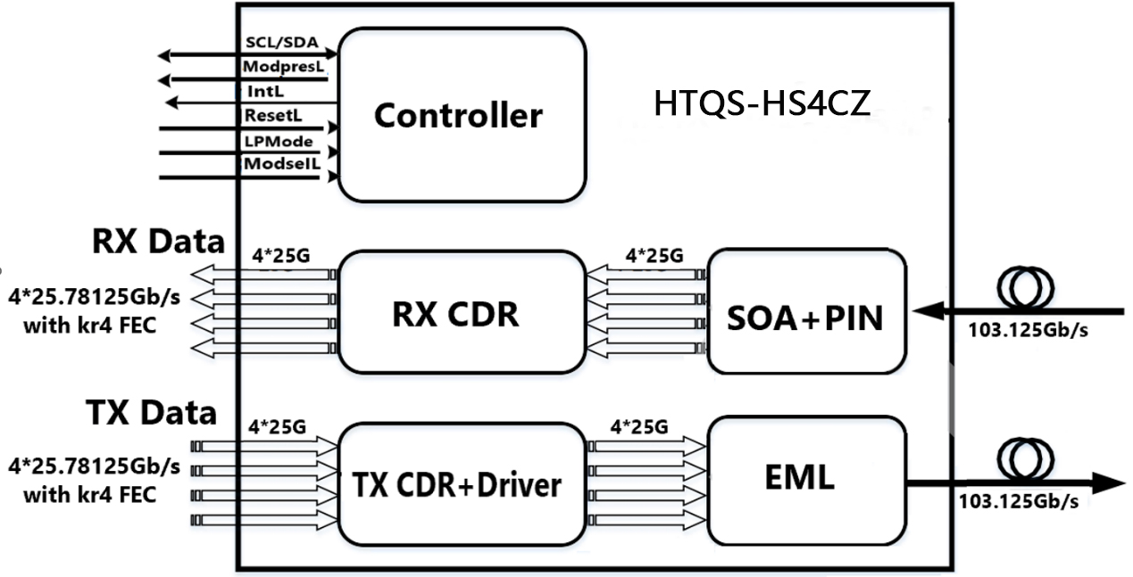
Figure1. Transceiver Block Diagram
ResetL:
The ResetL pin shall be pulled to Vcc in the module. A low level on the ResetL pin for longer than the minimum pulse length (t_Reset_init) initiates a complete module reset, returning all user module settings to their default state. Module Reset Assert Time (t_init) starts on the rising edge after the low level on the ResetL pin is released. During the execution of a reset (t_init) the host shall disregard all status bits until the module indicates a completion of the reset interrupt. The module indicates this by asserting "low" an IntL signal with the Data Not_Ready bit negated. Note that on power up (including hot insertion) the module should post this completion of reset interrupt without requiring a reset.
LPMode:
LPMode: The LPMode pin shall be pulled up to Vcc in the module. The pin is a hardware control used to put modules into a low power mode when high. By using the LPMode pin and a combination of the Power override, Power_set and High_Power_Class_Enable software control bits (Address A0h, byte 93 bits 0,1,2).
ModPrsL:
ModPrsL is pulled up to Vcc_Host on the host board and grounded in the module. The ModPrsL is asserted "Low" when inserted and deasserted "High" when the module is physically absent from the host connector.
IntL:
IntL is an output pin. When IntL is "Low", it indicates a possible module operational fault or a status critical to the host system. The host identifies the source of the interrupt using the 2-wire serial interface. The IntL pin is an open collector output and shall be pulled to host supply voltage on the host board. The INTL pin is deasserted "High" after completion of reset, when byte 2 bit 0 (Data Not Ready) is read with a value of '0' and the flag field is read .
IV. Pin Assignment and Pin Description
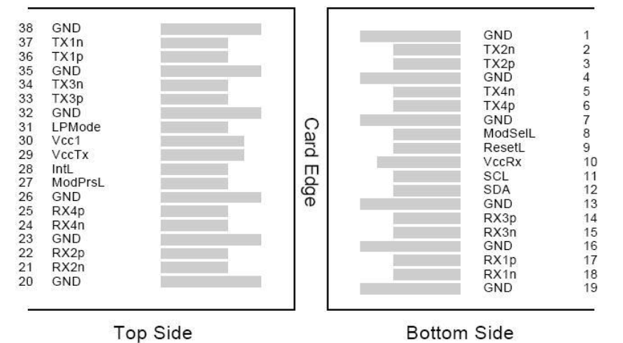
Figure2. Diagram of host board connector block pin numbers and names

Pin | Symbol | Name/Description | Notes
1 | GND | Transmitter Ground (Common with Receiver Ground) | 1
2 | Tx2n | Transmitter Inverted Data Input
3 | Tx2p | Transmitter Non-Inverted Data output
4 | GND | Transmitter Ground (Common with Receiver Ground) | 1
5 | Tx4n | Transmitter Inverted Data Input
6 | Tx4p | Transmitter Non-Inverted Data output
7 | GND | Transmitter Ground (Common with Receiver Ground) | 1
8 | ModSelL | Module Select
9 | ResetL | Module Reset
10 | VccRx | 3.3V Power Supply Receiver | 2
11 | SCL | 2-Wire serial Interface Clock
12 | SDA | 2-Wire serial Interface Data
13 | GND | Transmitter Ground (Common with Receiver Ground)
14 | Rx3p | Receiver Non-Inverted Data Output
15 | Rx3n | Receiver Inverted Data Output
16 | GND | Transmitter Ground (Common with Receiver Ground) | 1
17 | Rx1p | Receiver Non-Inverted Data Output
18 | Rx1n | Receiver Inverted Data Output
19 | GND | Transmitter Ground (Common with Receiver Ground) | 1
20 | GND | Transmitter Ground (Common with Receiver Ground) | 1
21 | Rx2n | Receiver Inverted Data Output
22 | Rx2p | Receiver Non-Inverted Data Output
23 | GND | Transmitter Ground (Common with Receiver Ground) | 1
24 | Rx4n | Receiver Inverted Data Output | 1
25 | Rx4p | Receiver Non-Inverted Data Output
26 | GND | Transmitter Ground (Common with Receiver Ground) | 1
27 | ModPrsl | Module Present
28 | IntL | Interrupt
29 | VccTx | 3.3V power supply transmitter | 2
30 | Vcc1 | 3.3V power supply | 2
31 | LPMode | Low Power Mode
32 | GND | Transmitter Ground (Common with Receiver Ground) | 1
33 | Tx3p | Transmitter Non-Inverted Data Input
34 | Tx3n | Transmitter Inverted Data Output
35 | GND | Transmitter Ground (Common with Receiver Ground) | 1
36 | Tx1p | Transmitter Non-Inverted Data Input
37 | Tx1n | Transmitter Inverted Data Output
38 | GND | Transmitter Ground (Common with Receiver Ground) | 1
Notes:
1. GND is the symbol for signal and supply (power) common for QSFP28 modules. All are common within the QSFP28 module and all module voltages are referenced to this potential unless otherwise noted. Connect these directly to the host board signal common ground plane.
2. VccRx, Vcc1 and VccTx are the receiving and transmission power suppliers and shall be applied concurrently. Recommended host board power supply filtering is shown below. Vcc Rx, Vcc1 and Vcc Tx may be internally connected within the QSFP28 transceiver module in any combination. The connector pins are each rated for a maximum current of 1000mA.
V. Electrical Characteristics
The following electrical characteristics are defined over the Recommended Operating Environment unless otherwise specified.
Parameter | Symbol | Min. | Typ. | Max | Unit | Notes
Power Consumption | p |  |  | 6.5 | W
Supply Current | Icc |  |  | 1876 | mA
Transmitter (each Lane)
Overload Differential Voltage pk-pk | TP1a |  |  | 900 | mV
Common Mode Voltage (Vcm) | TP1 | -350 |  | 2850 | mV | 1
Differential Termination Resistance Mismatch | TP1 |  |  | 10 | % | At 1MHz
Differential Return Loss (SDD11) | TP1 |  |  | See CEI-28G-VSR Equation 13-19 | dB
Common Mode to Differential conversion and Differential to Common Mode conversion (SDC11, SCD11) | TP1 |  |  | See CEI-28G-VSR Equation 13-20 | dB
Stressed Input Test | TP1a | See CEI-28G-VSR Section 13.3.11.2.1
Receiver
Differential Voltage, pk-pk | TP4 |  |  | 900 | mV
Common Mode Voltage (Vcm) | TP4 | -350 |  | 2850 | mV | 1
Common Mode Noise, RMS | TP4 |  |  | 10 | % | At 1MHz
Differential Return Loss (SDD22) | TP4 |  |  | See CEI-28G-VSR Equation 13-19 | dB
Common Mode to Differential conversion and Differential to Common Mode conversion (SDC22, SCD22) | TP4 |  |  | See CEI-28G-VSR Equation 13-21 | dB
Common Mode Return Loss (SCC22) | TP4 |  |  | -2 | dB | 2
Transition Time, 20 to 80% | TP4 | 9.5 |  |  | ps
Vertical Eye Closure (VEC) | TP4 |  |  | 5.5 | dB
Eye Width at 10-15 probability (EW15) | TP4 | 0.57 |  |  | UI
Eye Height at 10-15 probability (EH15) | TP4 | 228 |  |  | mV
Notes:
1. Vcm is generated by the host. Specification includes effects of ground offset voltage.
2. From 250MHz to 30GHz.

VI. Optical Characteristics
The following optical characteristics are defined over the Recommended Operating Environment unless otherwise specified.
Parameter |  | Symbol | Min. | Typical | Max | Unit | Notes
Transmitter
Lane wavelength（range） | L0 |  | 1294.53 | 1295.56 | 1296.59 | nm
Lane wavelength（range） | L1 |  | 1299.02 | 1300.05 | 1301.09 | nm
Lane wavelength（range） | L2 |  | 1303.54 | 1304.58 | 1305.63 | nm
Lane wavelength（range） | L3 |  | 1308.09 | 1309.14 | 1310.09 | nm
Signaling rate, each lane |  |  |  | 25.78125 |  | GBd
Side-mode suppression ratio | SMSR |  | 30
Total launch power | PT |  | 8.0 |  | 12.5 | dBm
Average launch power, each lane | Pavg |  | 2.0 |  | 4.5 | dBm
Extinction Ratio | ER |  | 6.0 |  |  | dB
Difference in Launch Power between any Two Lanes (OMA) | Ptx,diff |  |  |  | 3.6 | dB
Average launch power of OFF transmitter, each lane | Poff |  |  |  | -30 | dBm
Transmitter reflectance | R_{T} |  |  |  | -12 | dB
RIN₂₀OMA | RIN |  |  |  | -130 | dB/Hz
Optical Return Loss Tolerance | TOL |  |  |  | 20 | dB
Transmitter eye mask {X1, X2,X3, Y1, Y2, Y3} |  |  | {0.25, 0.4, 0.45, 0.25, 0.28, 0.4}
Receiver
Signaling rate, each lane |  |  |  | 25.78125 |  | GBd
Average Receive Power, each Lane |  |  | -28 |  | -7 | dBm
Receive Power (OMA), each Lane |  |  |  |  | -7 | dBm
Receiver reflectance |  | SEN1 |  |  | -20.9 | dBm | BER = 1x10⁻¹²
Receiver sensitivity Average, each lane |  | SEN2 |  |  | -28 | dBm | BER = 5x10⁻⁵
LOS Assert |  | LOSA | -40 |  |  | dBm
LOS Deassert |  | LOSD |  |  | -29 | dBm
LOS Hysteresis |  | LOSH | 0.5 |  |  | dB
VII. Digital Diagnostic Functions
The following digital diagnostic characteristics are defined over the normal operating conditions unless otherwise specified.
Parameter | Symbol | Min. | Max | Unit | Notes
Temperature monitor absolute error | DMI_ Temp | -3 | 3 | ºC | Over operating temp
Supply voltage monitor absolute error | DMI _VCC | -0.15 | 0.15 | V | Full operating range
RX power monitor absolute error | DMI_RX | -3 | 3 | dB
Bias current monitor | DMI_ bias | -10% | 10% | mA
TX power monitor absolute error | DMI_TX | -3 | 3 | dB
VIII. Mechanical Dimensions
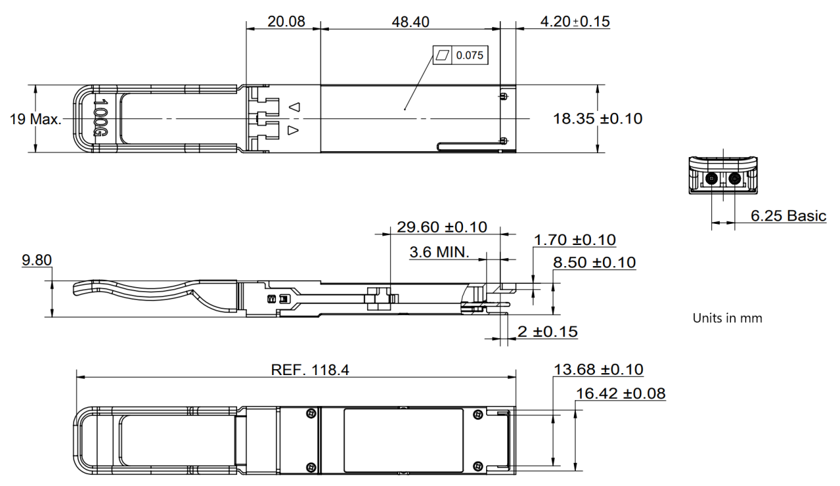
Figure2. Mechanical Outline

